Preface
Thank you for choosing Daymak’s Monaco electric bicycle. Electric bicycles are the latest innovation for those looking for transportation without the extra costs of licenses, insurance, and the constantly rising gas prices. The Monaco electric bicycle is classified like any other bicycle with various advantages one would find in a typical scooter: turn signals, head lights, brake lights, individual brakes for the front and back wheels, and many more. Above all else, the most attractive characteristic of electric bicycles is the fact that they run on electricity! That is, electric bicycles (or ebikes for short) can last easily up to 50km per charge, with each charge costing merely 10 cents or less! The Monaco is environmentally friendly (for our green customers) creating no pollution, produces little to no noise, and is proven to be extremely safe.
The Monaco comes with many features including: great looking design, high battery life, holds a high charge, high-efficient direct current batteries, lights for traveling at night, an indicator to know how much charge is left in the battery, speedometer, and even an alarm system! You can also easily remove the battery from the bike and charge it directly.
The Monaco is extremely easy to operate. It can function both with physical power (through pedaling) or by throttling; it even comes with a function called pedal assist. The pedal assist system tells the bike to send power to the motor whenever the operator pedals the bike and turns off when the operator stops pedaling. This makes pedaling that much easier for when you’re looking to conserve some battery or just looking to operate it as a bike.

Safety Instructions

Please follow the guide below for proper maintenance and operation.

Safe operation
For the safety of yourself and others, please observe and follow all traffic rules and laws. Please operate the ebike according to the ebike laws of your area. If possible, please ride the ebike along the side of the road and do not over-take any vehicle.
Due to the speed of the ebike, it is advised that the youngest age of operation be 16 years. Also, please pay attention to your speed of operation during rainy or snowy conditions. Be sure to maintain a safe distance from any obstacles ahead.
Driving
Turn the ebike on by placing the key into the ignition and turning it clockwise to the “ON” position. The battery meter should indicate that the bike is on and operational and will indicate the voltage available in the battery.
Please check to ensure that the rear wheel is not locked before operation. (Your ebike comes with a separate key for the rear wheel lock)
Hold firmly onto the handles and slowly turn the throttle (the right handlebar) anti/counter clockwise. The motor will begin to kick in and propel the bike forward. If it is your first time, please ensure that you are comfortable with balancing and maneuvering the bike before attempting full throttle.
Releasing the throttle will cut off power to the motor and the bike will begin to slow down. Use the brake handles to slow down or to stop the bike. Power will be cut from the motor once the brake handles are depressed; the throttle will not work so long as the handles are depressed.
There is a button on your left handlebar for the horn. When parking your bike, you can set the alarm system by pressing the horn button while the bike is turned “OFF”. Also on the left handlebar is the turn signal with 3 positions: left (left turn), middle (neutral), and right (right turn).
When riding at night, please ensure that the lights are turned on for your own safety. You can find the light switch on your right handlebar. If the button is switch to the right, the lights are off. In the middle position, the head lights will turn on. On
the left handlebar is a switch to control normal headlight power or high-beams. Please observe traffic laws when using high-beam lights.
A battery meter showing 0 or 1 light indicates that your battery is low or empty and requires you to charge immediately.
To park the bike, use the kick stand available on the left side of the bike. Step on the kickstand and apply pressure down while lifting the back-side of the wheel with you’re your right arm. When you park the bike, please ensure that you turn off the bike and remove the key to prevent theft of the bike. Some safety features already listed above is repeated below:

- Lock the rear wheel by opening the cover of the lock to the left of the wheel (facing forward) place and turn the key accordingly. Upon turning the wheel, you should feel a “click” indicating that the wheel has locked.

- While the vehicle is parked and turned off, you can arm the alarm system by simply pressing the horn. Upon pressing the horn, you will hear 2-3 “beeps” indicating that the alarm is set. To turn off the alarm, simply put your key into the ignition and turn the vehicle on.

Special Notice
When turning on the bike, please ensure that the throttle is not engaged. Starting the bike with the throttle turned may affect the battery life and the maximum speeds for the duration of the ride. Frequently starting the bike in this manner can and will affect the mileage of the battery. Always remember to charge the battery after the voltage has depleted. If the bike is not used for a long time, please remember to charge it completely at least once every half month (or 15 days). Proper maintenance of the battery will increase the life of the battery.
If stuck in mud, snow, sludge, slush, etc. please remove the bike from the place you are stuck by getting off the bike and moving it by feet.
If you remove the battery from the bike, please do not allow metal to touch the negative/positive plates of the battery to avoid damage to the battery.

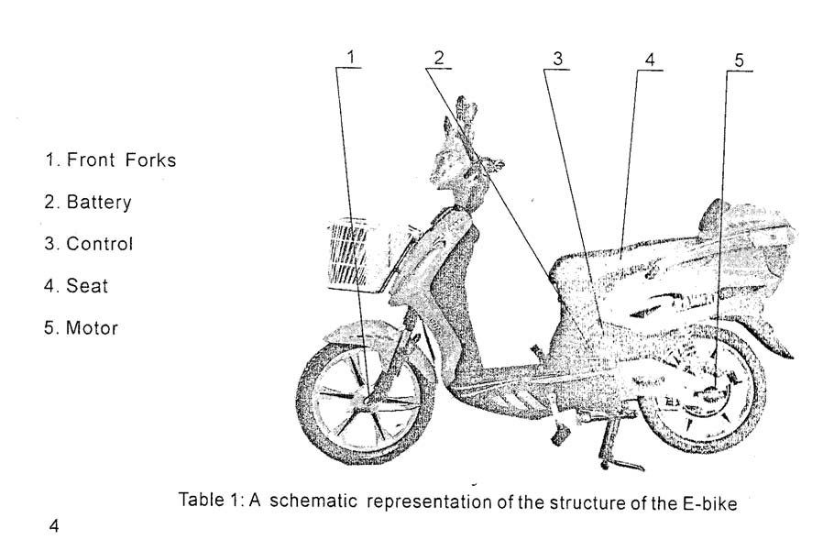
Battery and Charger
The battery box is detachable from the frame and can be removed from the bike when you require charging. Please be careful when removing the battery, as it is heavy. The charger of the bike is equipped with a function that protects the battery from overcharging. The light on the charger changes during the recharging state.

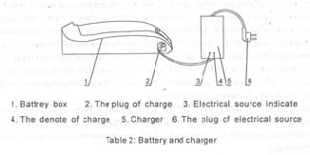

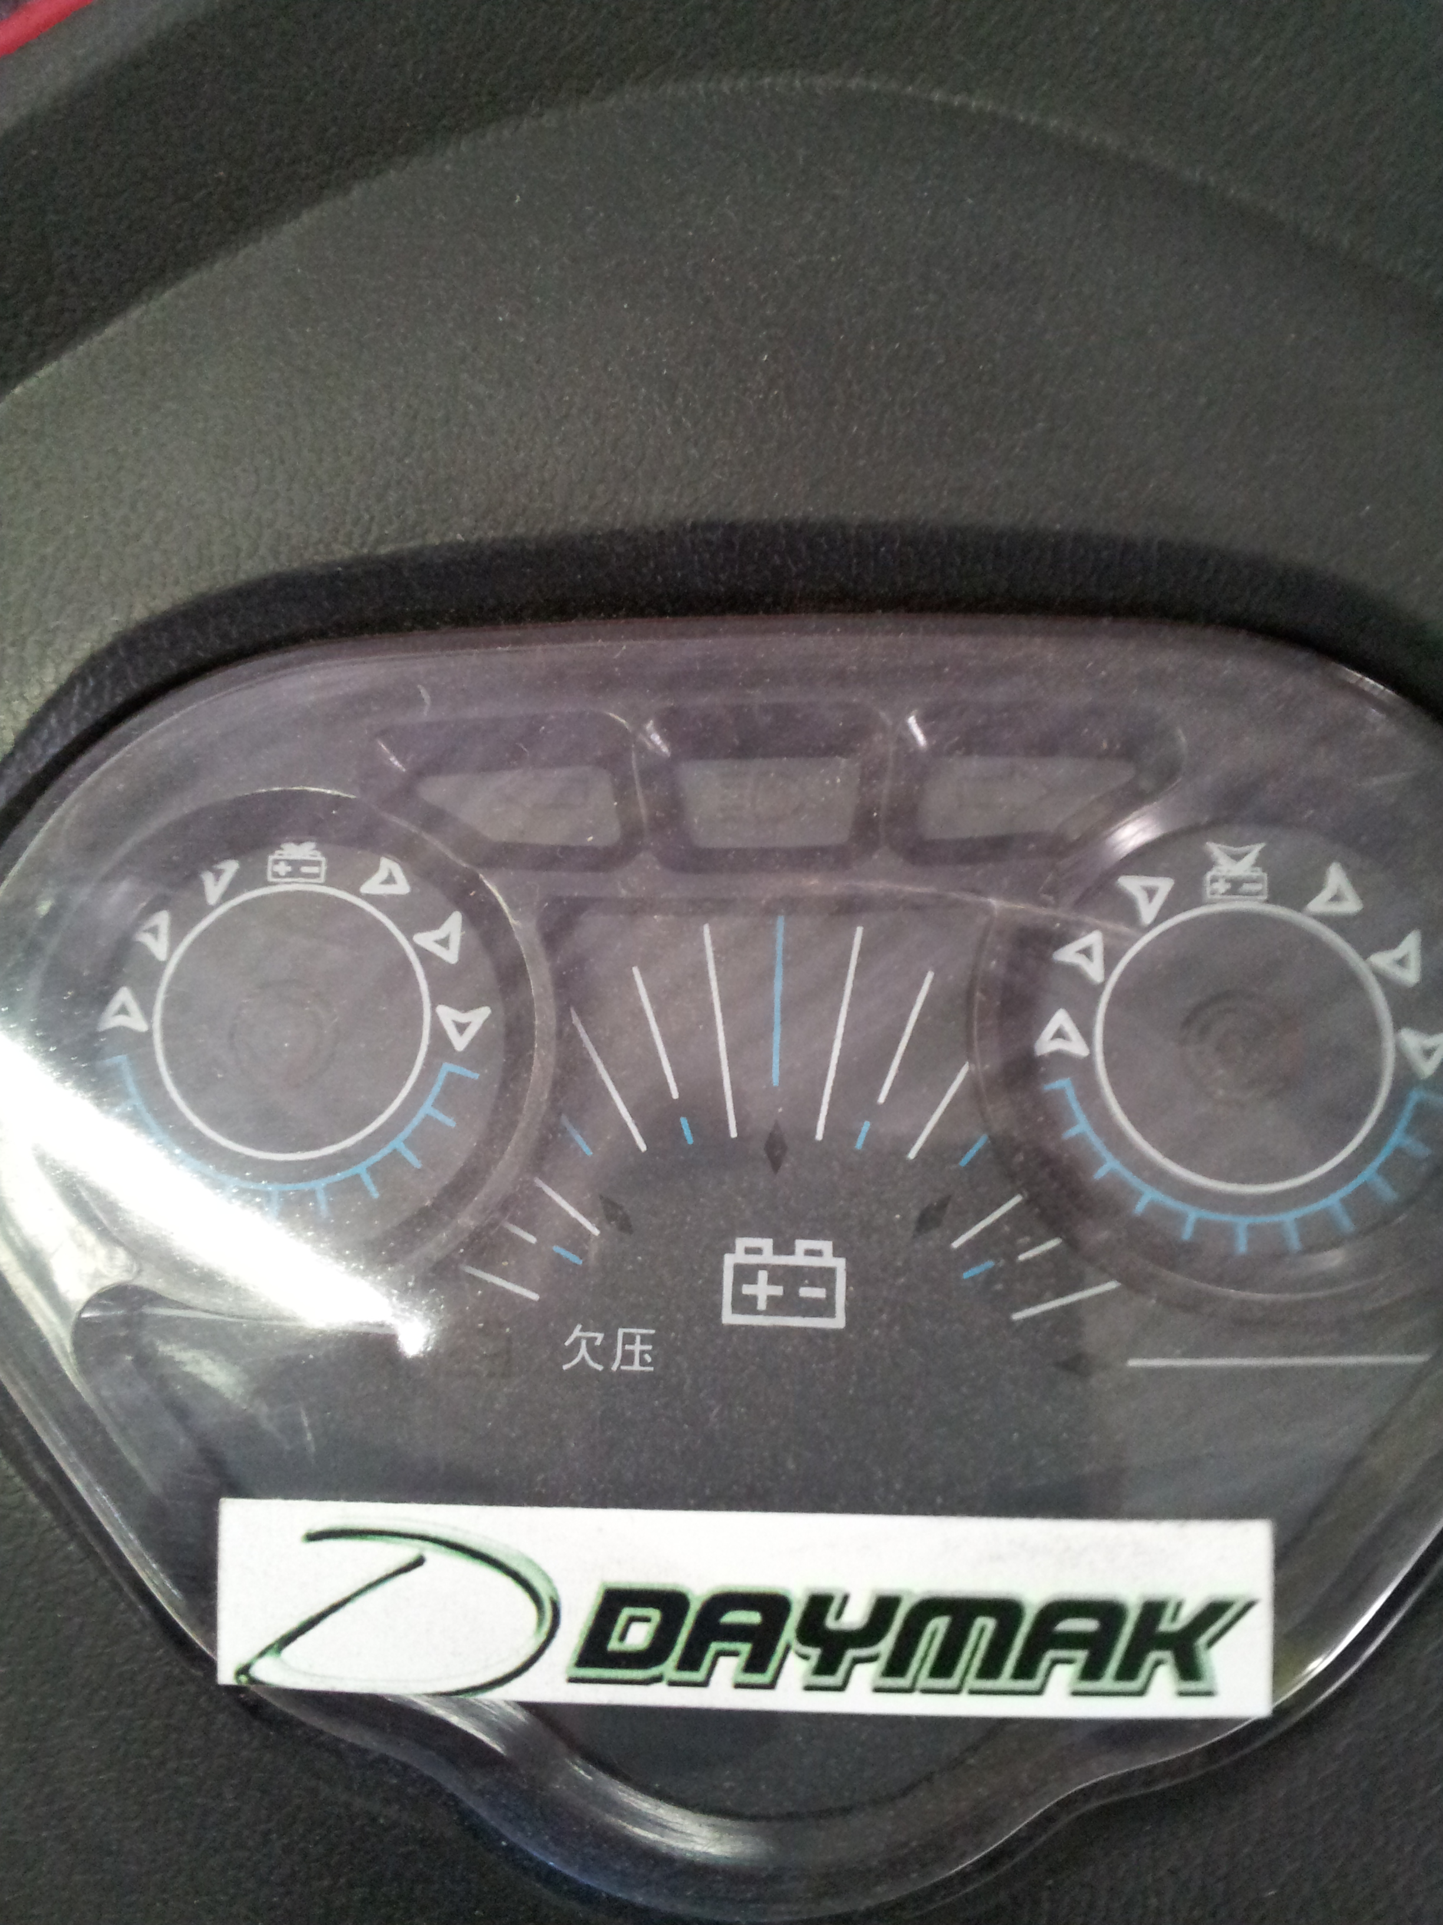

Turn Signal Indicators

Battery Level Indicators
Headlight Indicators

The area that you will be working on is just under the center of the handlebars. You can find the nut that attaches the core pole of the bike to the wheel just under the dash of the bike. There should be a plastic cover (clearly visible) that is about 2 inches long and 1 inch wide. Please remove this plastic cover to access the nut to the core pole.

1. Loosen the nut on the core pole and adjust the handlebars and front wheel to the desired position. Retighten nut DO NOT OVERTIGHTEN!
Assembly and Adjustment

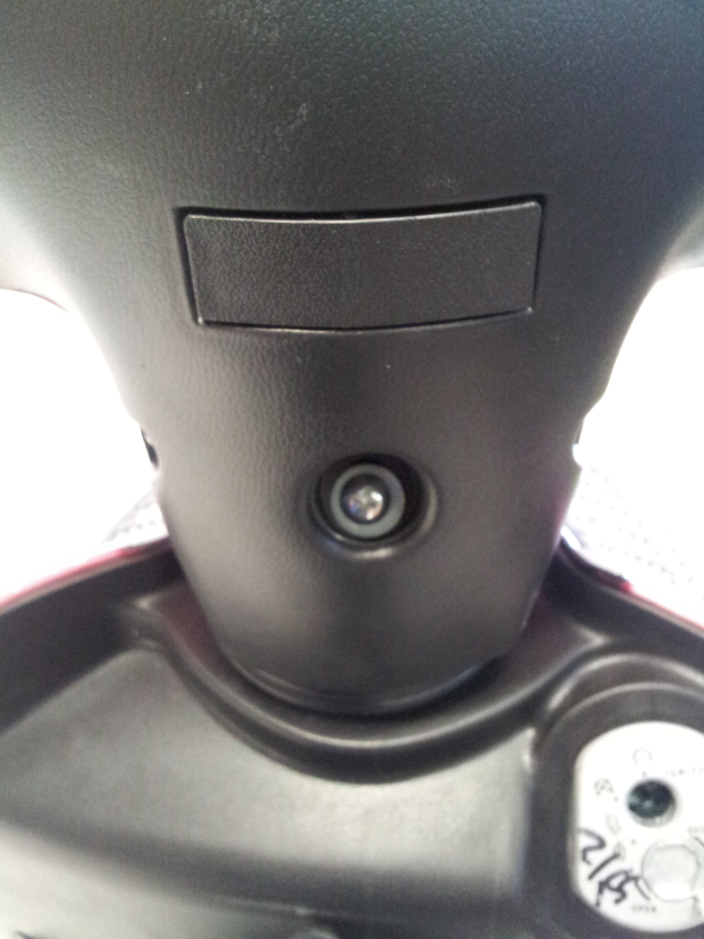

Brakes
2. Adjust the performance of the front brakes by turning the screw clockwise. Make sure the distance between the brake strap and the wheel rim is less than 3mm apart. Keep the surface away from the side of rim or else the wheel cannot brake properly. When the drum brakes have been reduced by 1/3, please change for a new one.

3. Adjust the rear brakes by loosening the screw/clamp and pulling more wire through the fixture. Tighten the screw to secure the wire when desired braking is achieved. Loosen the screw and reverse the procedure if the wheel will not turn freely when brakes are not applied. 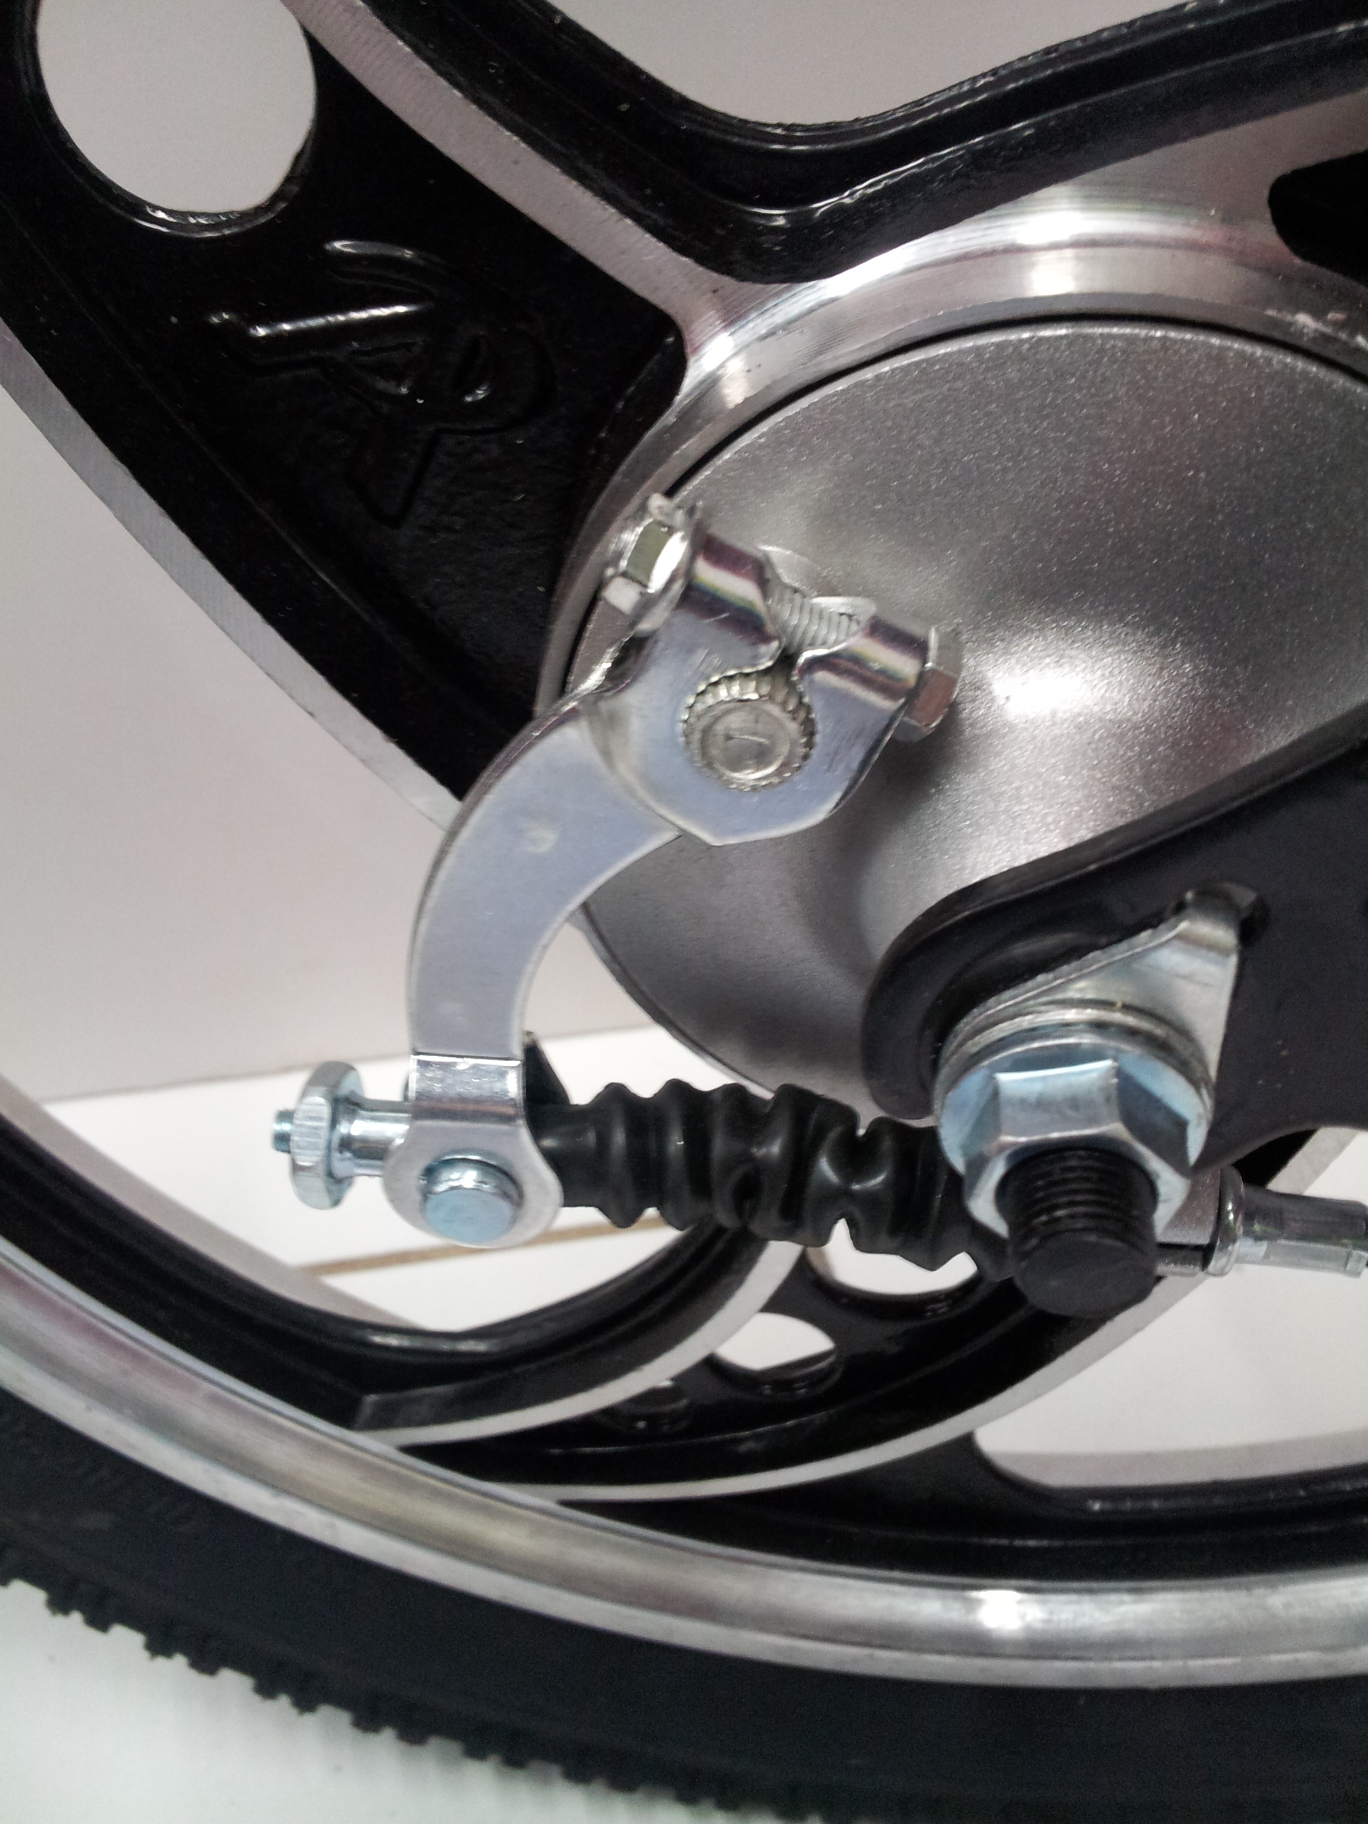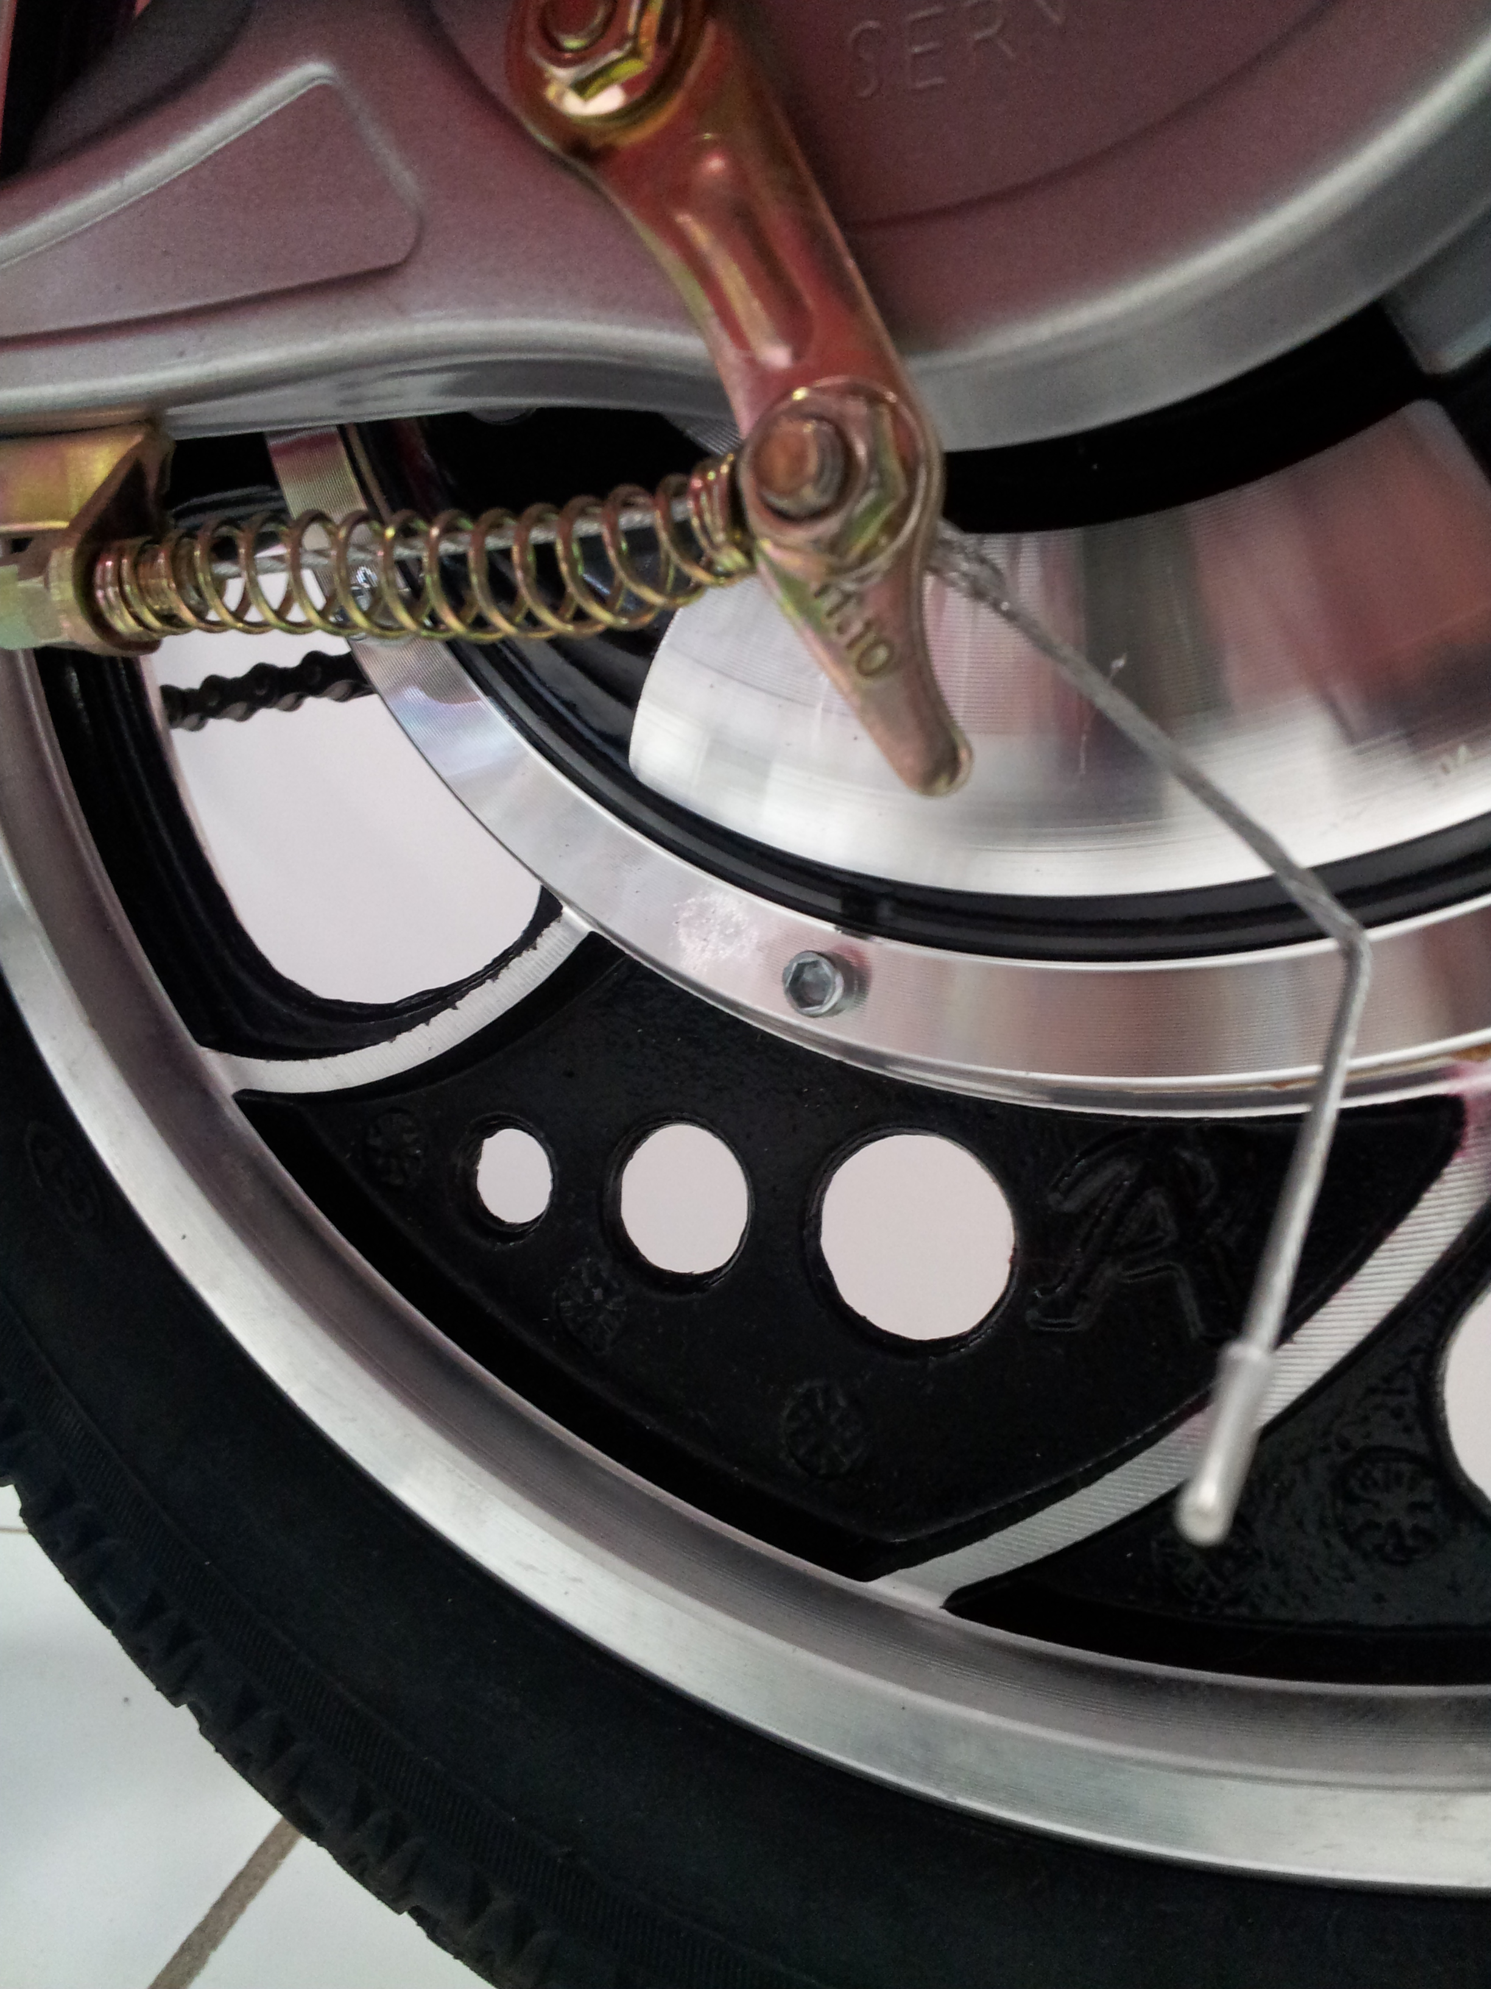
Front Wheels
4. Loosening the nuts on both sides of the front axle will allow you to remove the front wheel. When replacing the front wheel, fix the wheel on the axle appropriately and tighten the nuts accordingly. The two bolts should be secured with the same distance tightened onto the fork to keep the wheel in the central alignment.
Chain
5. To adjust the tightness of the chain, loosen the two nuts holding the rear wheel to the axle. Loosen enough so that you can slide the wheel back to tighten/loosen the chain. The tightness of the chain can be measure by pressing a finger on the center of the chain down. The distance that the chain should move is 15mm.
Rear Wheel
The rear motor hub comes with a locking mechanism that prevents the motor from moving when parked; this is a theft prevention feature. In order to engage the lock, place the key (there is a set specific to the lock itself) into the keyhole and turn counter-clockwise to lock and clockwise to unlock. Please make sure to unlock your motor before every ride!
If there is any issue with the rear wheel, please refrain from doing any work on it. The rear wheel houses the motor hub of the e-bike and any damage to it can compromise the functionality of the bike. Please bring the bike into one of our shops for repairs. Taking it anywhere else will void all warranty of the e-bike and you will take full responsibility for all damages to the bike.

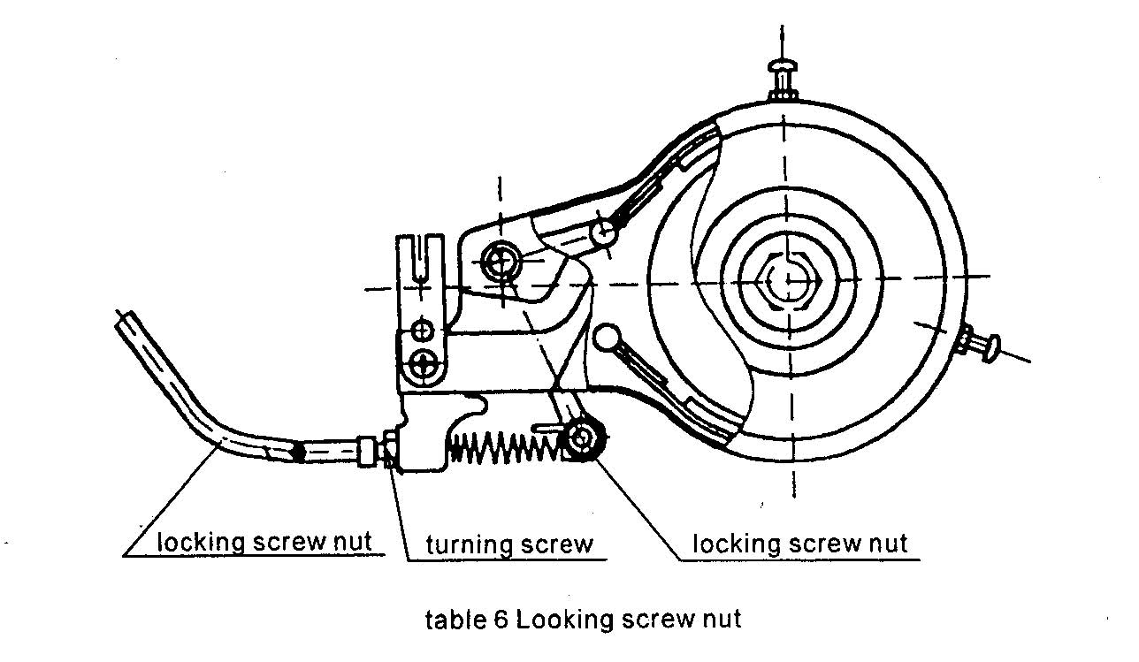

Safety and Maintenance
The bicycle must be maintained properly in order for it to provide you with utmost quality and overall safety.

1. Check to see whether the rear wheel (motor) makes loud/weird/unusual sounds upon turning. If yes, please take it to our service department to prevent further damage to the motor.

2. Check to make sure all external and internal components are connected and tightened. This includes the wiring of the controller, the tightness of bolts, and so forth.

3. Check the braking system: including lights and reaction time of the brakes.

4. Try to keep your bicycle as clean as possible after each ride.

5. Apply grease to the front and back axles periodically for better functionality. Also keep the brake wires well lubricated.

